Welcome
Trinity Lutheran Church
Lutheran Church—Missouri Synod
A Stephen Ministry Congregation

1354 South Otsego Avenue
Gaylord, Michigan 49735
Church Phone: (989) 732-4816

Church Email: secretary@trinitygaylord.com
www.trinitygaylord.com

Office Hours: Monday through Friday 9am – 1pm

OUR PURPOSE
…is to LOVE GOD, LOVE OTHERS, AND SERVE THE WORLD by worshiping the Lord Jesus, bringing our members into Christ-like maturity, and equipping them through Word and Sacrament for their mission and ministry. We go heart to heart into the world with Jesus, sharing His love, caring for one another, praying, and bringing the lost into a relationship with Christ, by the working of the Holy Spirit.

January 30, 2022
(Fourth Sunday after the Epiphany)
Preacher: Rev. Ken Bernthal`

ABOUT OUR WORSHIP
We welcome all who gather here today! We are blessed to celebrate together the mercy, grace, and love we have from God through the death and resurrection of our Lord Jesus Christ.

Children: Families with children are very welcome here. Having children in church is important so they can begin to learn about their faith in Jesus, and it’s good for the whole congregation to see. Please feel comfortable keeping “squirmy” kids in the service. This is where they belong, too!

Pew Cards: Guests and Members, please fill out the Guest/Member card located on the back of the pew in front of you and pass it to the end of the aisle. If you forget you can put it in the offering plate on your way out.

If standing is difficult: Please feel free to remain seated during any portion of the service. Please let an Elder or Usher know if you need communion in your pew seat.

About our celebration of Holy Communion: We celebrate the Lord’s Supper in the confession and glad confidence that, as he says, our Lord gives into our mouths not only bread and wine but his very body and blood to eat and to drink for the forgiveness of sins and to strengthen our union with him and with one another. Our Lord invites to his table those who trust his words, repent of all sin, and set aside any refusal to forgive and love as he forgives and loves us, that they may show forth his death until he comes.

Because those who eat and drink our Lord’s body and blood contrary to that which is stated above do so to their great harm, and also because Holy Communion is a confession of the faith which is confessed at this altar. Anyone who is not yet instructed, in doubt, or who hold a confession differing from that of the Lutheran Church—Missouri Synod, and yet desire to receive the sacrament, are asked first to speak with Pastor. Those not communing are still invited to come forward for a blessing from Pastor, and you may indicate this by crossing your arms over your chest.
TTTTTT

GREETING

P Peace be with you.
C And also with you.
T ORDER OF SERVICE T
(The liturgy is from Divine Service Setting four LSB pg. 203ff)

OPENING HYMN
O Worship the King LSB 804
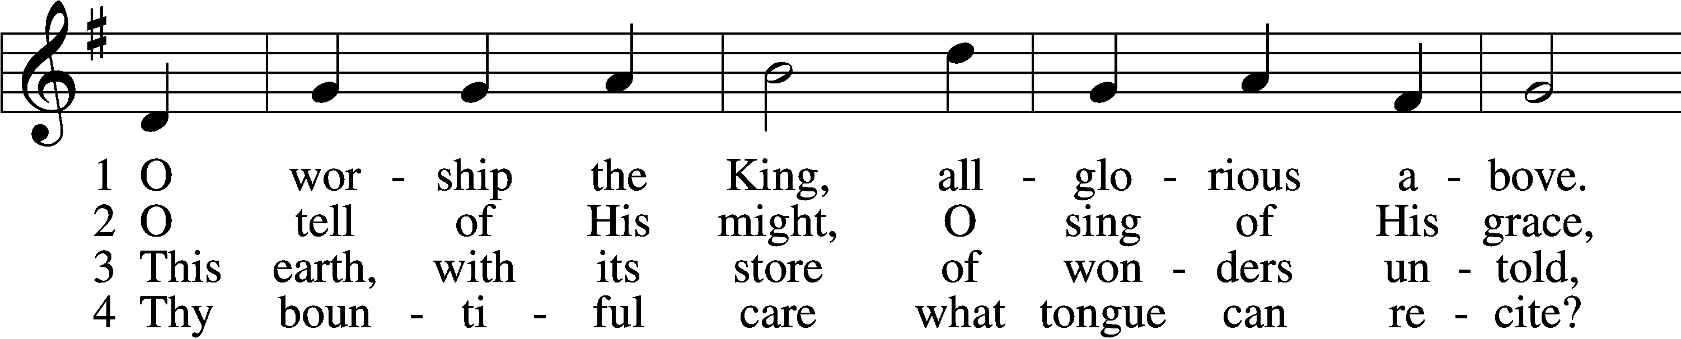
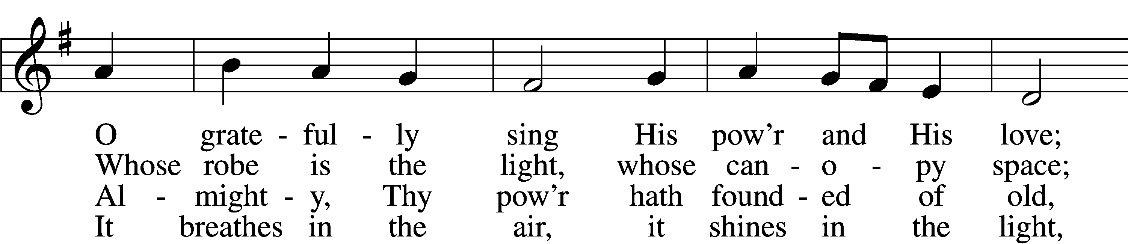
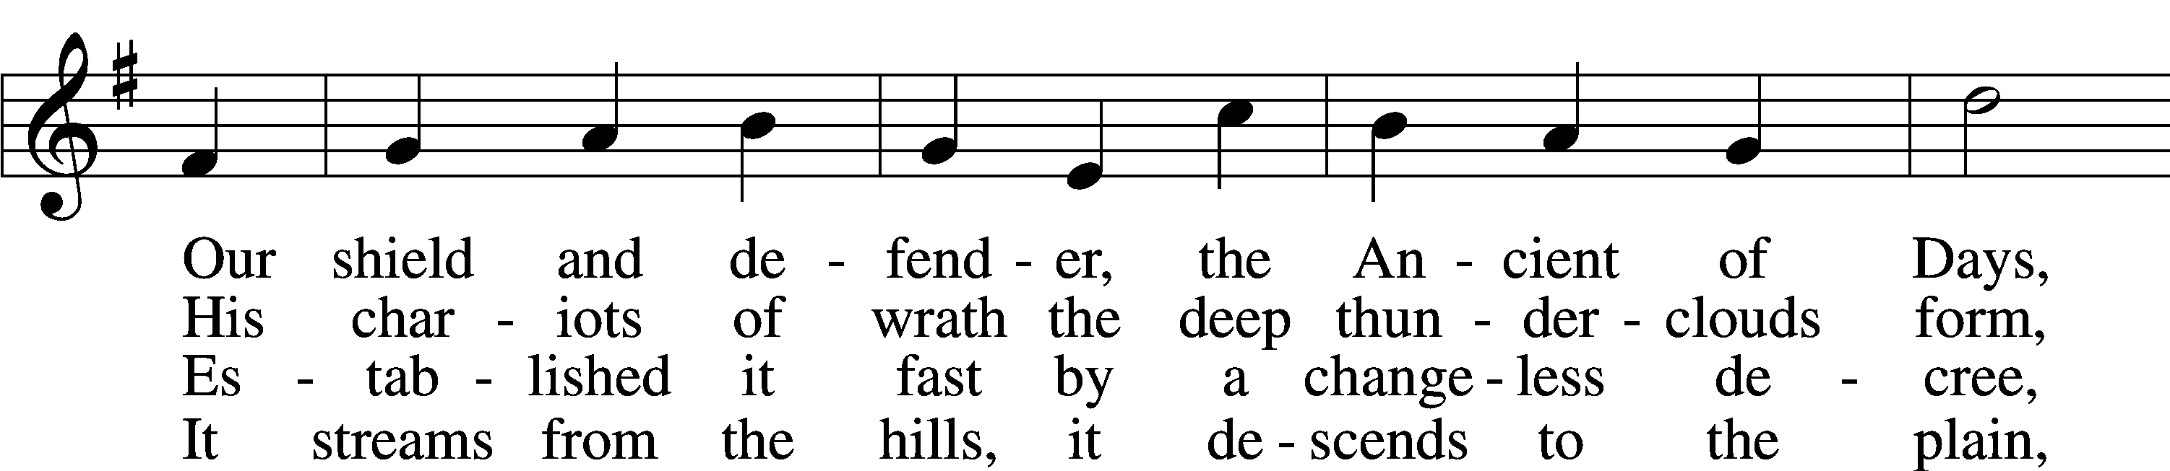
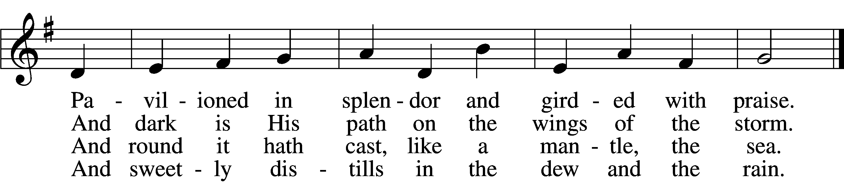

5 Frail children of dust 6 O measureless Might,
and feeble as frail, ineffable Love,
In Thee do we trust, While angels delight
nor find Thee to fail. to hymn Thee above,
Thy mercies, how tender, Thy humbler creation,
how firm to the end, though feeble their lays,
Our maker, defender, though feeble their lays,
redeemer, and friend! shall sing to Thy praise.
Text and tune: Public domain

Please stand as able
CONFESSION and ABSOLUTION
The sign of the cross may be made by all in remembrance of their Baptism.

P In the name of the Father and of the T Son and of the Holy Spirit.
C Amen.
P Our help is in the name of the Lord,
C who made heaven and earth.
P If You, O Lord, kept a record of sins, O Lord, who could stand?
C But with You there is forgiveness; therefore, You are feared.
P Since we are gathered to hear God’s Word, call upon Him in prayer and praise, and receive the body and blood of our Lord Jesus Christ in the fellowship of this altar, let us first consider our unworthiness and confess before God and one another that we have sinned in thought, word, and deed, and that we cannot free ourselves from our sinful condition. Together as His people let us take refuge in the infinite mercy of God, our heavenly Father, seeking His grace for the sake of Christ, and saying: God, be merciful to me, a sinner.
C Almighty God, have mercy upon us, forgive us our sins, and lead us to everlasting life. Amen.
P Almighty God, merciful Father, in Holy Baptism You declared us to be Your children and gathered us into Your one, holy Church, in which You daily and richly forgive us our sins and grant us new life through Your Spirit. Be in our midst, enliven our faith, and graciously receive our prayer and praise; through Your Son, Jesus Christ, our Lord.
C Amen.
SERVICE OF THE WORD
INTROIT Psalm 10:16–18; antiphon: v. 12
P Arise, O Lord; O God, lift up your hand;
forget not the afflicted.
C The Lord is king forever and ever;
the nations perish from his land.
P O Lord, you hear the desire of the afflicted;
you will strengthen their heart;
C you will incline your ear to do justice to the fatherless and the oppressed,
so that man who is of the earth may strike terror no more.

Glory be to the Father and to the Son
and to the Holy Spirit;
as it was in the beginning,
is now, and will be forever. Amen.
P Arise, O Lord; O God, lift up your hand;
forget not the afflicted.

SERVICE OF THE WORD
KYRIE LSB 204
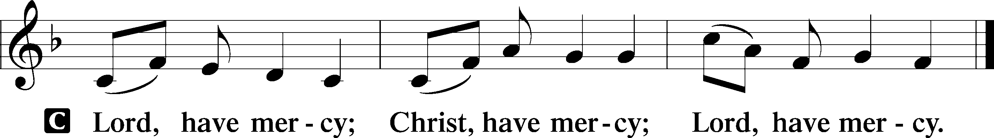

HYMN OF PRAISE
GLORIA in EXCELSIS LSB 204
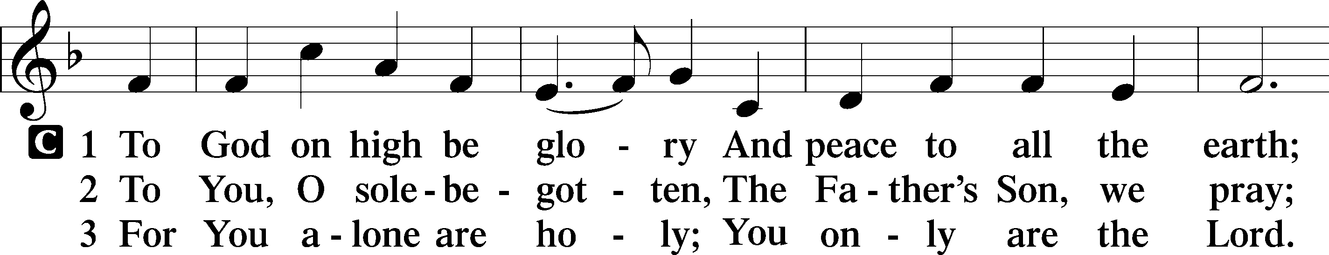
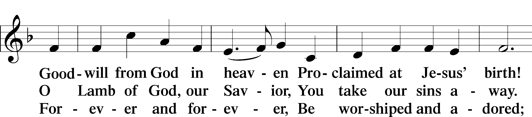
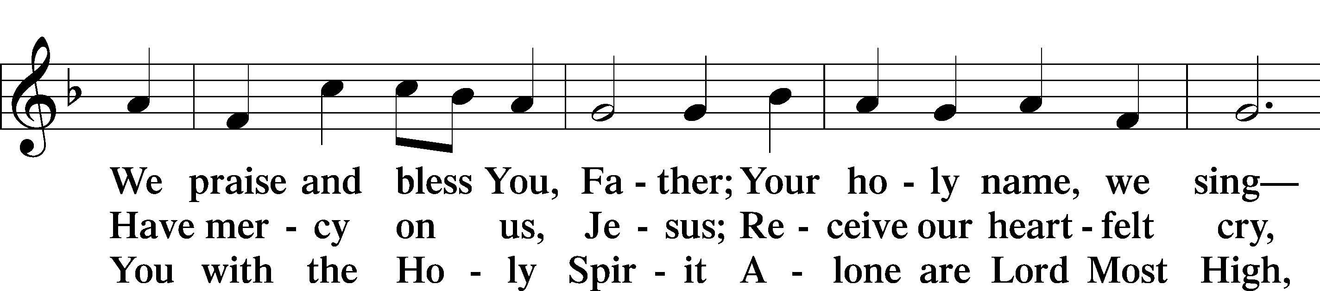
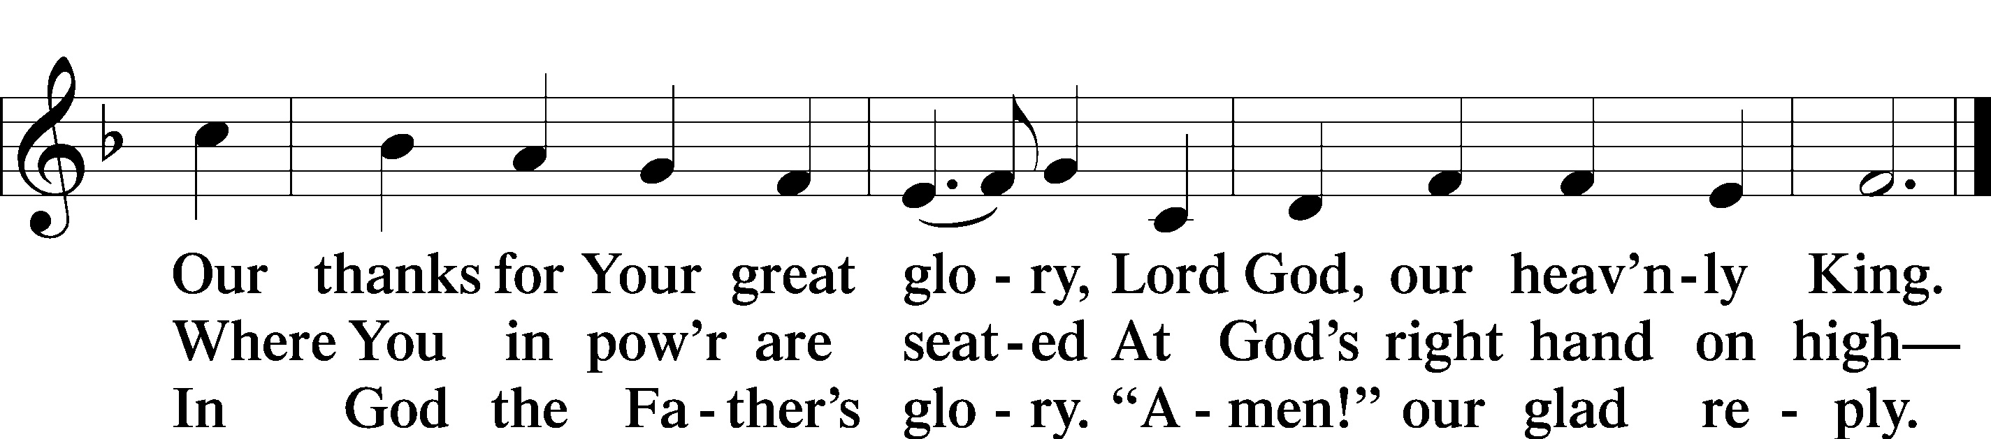

SALUTATION AND COLLECT OF THE DAY
P The Lord be with you.
C And also with you.
P Let us pray.
Almighty God, You know we live in the midst of so many dangers that in our frailty we cannot stand upright. Grant strength and protection to support us in all dangers and carry us through all temptations; through Jesus Christ, Your Son, our Lord, who lives and reigns with You and the Holy Spirit, one God, now and forever.
C Amen.

Please be seated

OLD TESTAMENT READING Jeremiah 1:4–19

⁴Now the word of the Lord came to me, saying,
⁵“Before I formed you in the womb I knew you,
and before you were born I consecrated you;
I appointed you a prophet to the nations.”
⁶Then I said, “Ah, Lord God! Behold, I do not know how to speak, for I am only a youth.” ⁷But the Lord said to me,
“Do not say, ‘I am only a youth’;
for to all to whom I send you, you shall go,
and whatever I command you, you shall speak.
⁸Do not be afraid of them,
for I am with you to deliver you,
declares the Lord.”
⁹Then the Lord put out his hand and touched my mouth. And the Lord said to me,
“Behold, I have put my words in your mouth.
¹⁰See, I have set you this day over nations and over kingdoms,
to pluck up and to break down,
to destroy and to overthrow,
to build and to plant.”
¹¹And the word of the Lord came to me, saying, “Jeremiah, what do you see?” And I said, “I see an almond branch.” ¹²Then the Lord said to me, “You have seen well, for I am watching over my word to perform it.”
¹³The word of the Lord came to me a second time, saying, “What do you see?” And I said, “I see a boiling pot, facing away from the north.” ¹⁴Then the Lord said to me, “Out of the north disaster shall be let loose upon all the inhabitants of the land. ¹⁵For behold, I am calling all the tribes of the kingdoms of the north, declares the Lord, and they shall come, and every one shall set his throne at the entrance of the gates of Jerusalem, against all its walls all around and against all the cities of Judah. ¹⁶And I will declare my judgments against them, for all their evil in forsaking me. They have made offerings to other gods and worshiped the works of their own hands. ¹⁷But you, dress yourself for work; arise, and say to them everything that I command you. Do not be dismayed by them, lest I dismay you before them. ¹⁸And I, behold, I make you this day a fortified city, an iron pillar, and bronze walls, against the whole land, against the kings of Judah, its officials, its priests, and the people of the land. ¹⁹They will fight against you, but they shall not prevail against you, for I am with you, declares the Lord, to deliver you.”

P This is the Word of the Lord.
C Thanks be to God.

EPISTLE 1 Corinthians 12:31b—13:13
I will show you a still more excellent way.
¹If I speak in the tongues of men and of angels, but have not love, I am a noisy gong or a clanging cymbal. ²And if I have prophetic powers, and understand all mysteries and all knowledge, and if I have all faith, so as to remove mountains, but have not love, I am nothing. ³If I give away all I have, and if I deliver up my body to be burned, but have not love, I gain nothing.
⁴Love is patient and kind; love does not envy or boast; it is not arrogant ⁵or rude. It does not insist on its own way; it is not irritable or resentful; ⁶it does not rejoice at wrongdoing, but rejoices with the truth. ⁷Love bears all things, believes all things, hopes all things, endures all things.
⁸Love never ends. As for prophecies, they will pass away; as for tongues, they will cease; as for knowledge, it will pass away. ⁹For we know in part and we prophesy in part, ¹⁰but when the perfect comes, the partial will pass away. ¹¹When I was a child, I spoke like a child, I thought like a child, I reasoned like a child. When I became a man, I gave up childish ways. ¹²For now we see in a mirror dimly, but then face to face. Now I know in part; then I shall know fully, even as I have been fully known.
¹³So now faith, hope, and love abide, these three; but the greatest of these is love.

P This is the Word of the Lord.
C Thanks be to God.

Please stand as able

ALLELUIA AND VERSE LSB 205
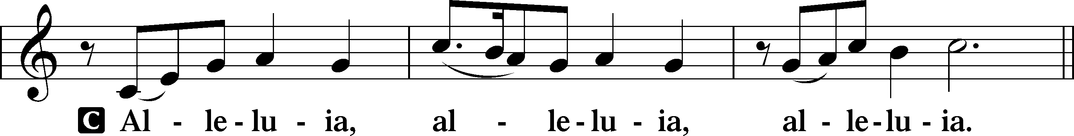

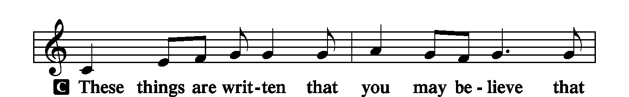
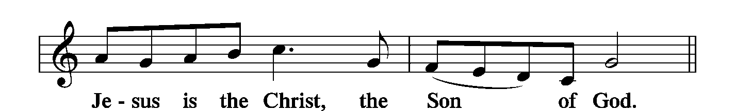
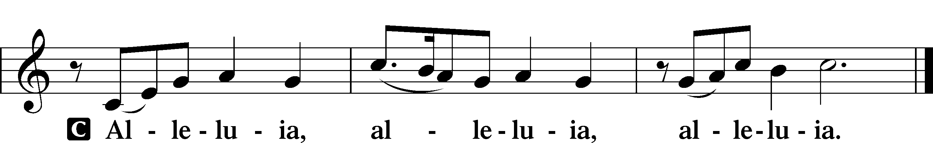

HOLY GOSPEL Luke 4:31–44
P The Holy Gospel according to St. Luke, the fourth chapter.
C Glory to You, O Lord.

³¹[Jesus] went down to Capernaum, a city of Galilee. And he was teaching them on the Sabbath, ³²and they were astonished at his teaching, for his word possessed authority. ³³And in the synagogue there was a man who had the spirit of an unclean demon, and he cried out with a loud voice, ³⁴“Ha! What have you to do with us, Jesus of Nazareth? Have you come to destroy us? I know who you are—the Holy One of God.” ³⁵But Jesus rebuked him, saying, “Be silent and come out of him!” And when the demon had thrown him down in their midst, he came out of him, having done him no harm. ³⁶And they were all amazed and said to one another, “What is this word? For with authority and power he commands the unclean spirits, and they come out!” ³⁷And reports about him went out into every place in the surrounding region.
³⁸And he arose and left the synagogue and entered Simon’s house. Now Simon’s mother-in-law was ill with a high fever, and they appealed to him on her behalf. ³⁹And he stood over her and rebuked the fever, and it left her, and immediately she rose and began to serve them.
⁴⁰Now when the sun was setting, all those who had any who were sick with various diseases brought them to him, and he laid his hands on every one of them and healed them. ⁴¹And demons also came out of many, crying, “You are the Son of God!” But he rebuked them and would not allow them to speak, because they knew that he was the Christ.
⁴²And when it was day, he departed and went into a desolate place. And the people sought him and came to him, and would have kept him from leaving them, ⁴³but he said to them, “I must preach the good news of the kingdom of God to the other towns as well; for I was sent for this purpose.” ⁴⁴And he was preaching in the synagogues of Judea.

P This is the Gospel of the Lord.
C Praise to You, O Christ.

NICENE CREED
C I believe in one God,
the Father Almighty,
maker of heaven and earth
and of all things visible and invisible.
And in one Lord Jesus Christ,
the only-begotten Son of God,
begotten of His Father before all worlds,
God of God, Light of Light,
very God of very God,
begotten, not made,
being of one substance with the Father,
by whom all things were made;
who for us men and for our salvation came down from heaven
and was incarnate by the Holy Spirit of the virgin Mary
and was made man;
and was crucified also for us under Pontius Pilate.
He suffered and was buried.
And the third day He rose again according to the Scriptures
and ascended into heaven
and sits at the right hand of the Father.
And He will come again with glory to judge both the living and the dead,
whose kingdom will have no end.
And I believe in the Holy Spirit,
the Lord and giver of life,
who proceeds from the Father and the Son,
who with the Father and the Son together is worshiped and glorified,
who spoke by the prophets.
And I believe in one holy Christian and apostolic Church,

I acknowledge one Baptism for the remission of sins,
and I look for the resurrection of the dead
and the life T of the world to come. Amen.

Please be seated

ALL GOD’S CHILDREN – TALK

HYMN OF THE DAY

Thy Strong Word LSB 578 (Please stand on st. 6)
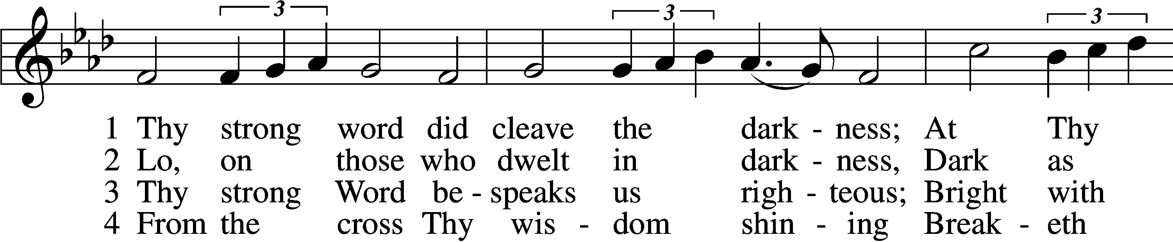
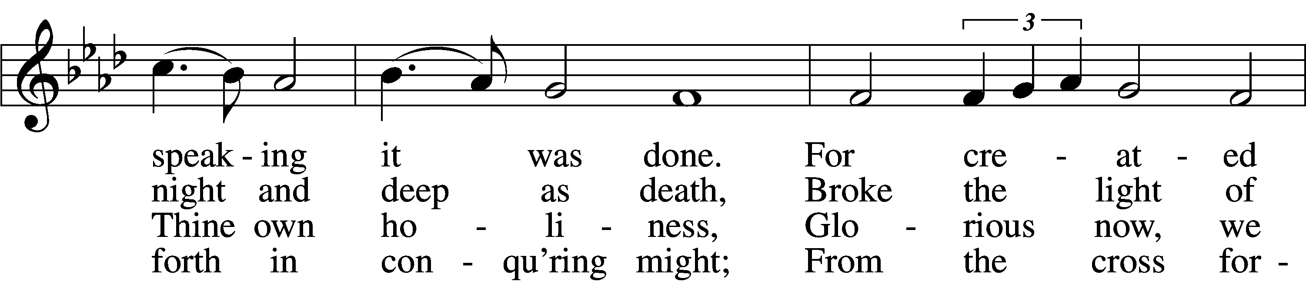
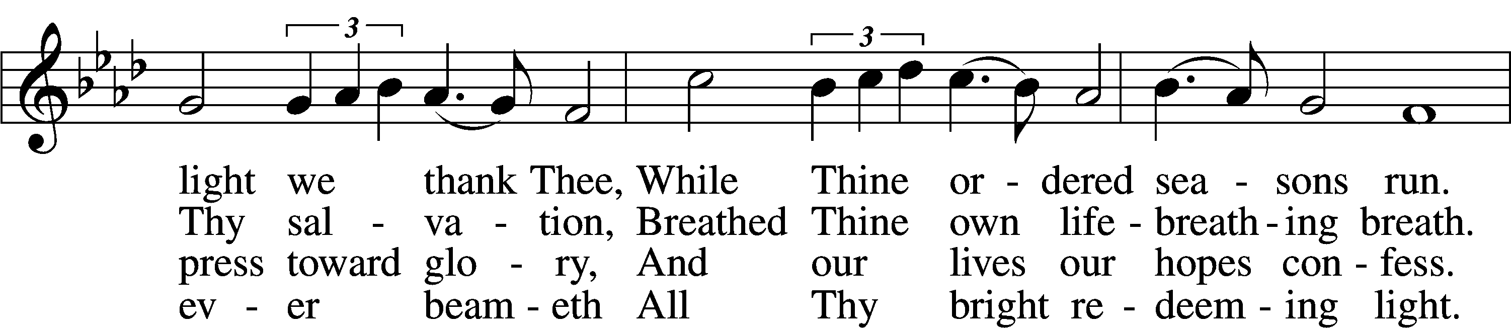
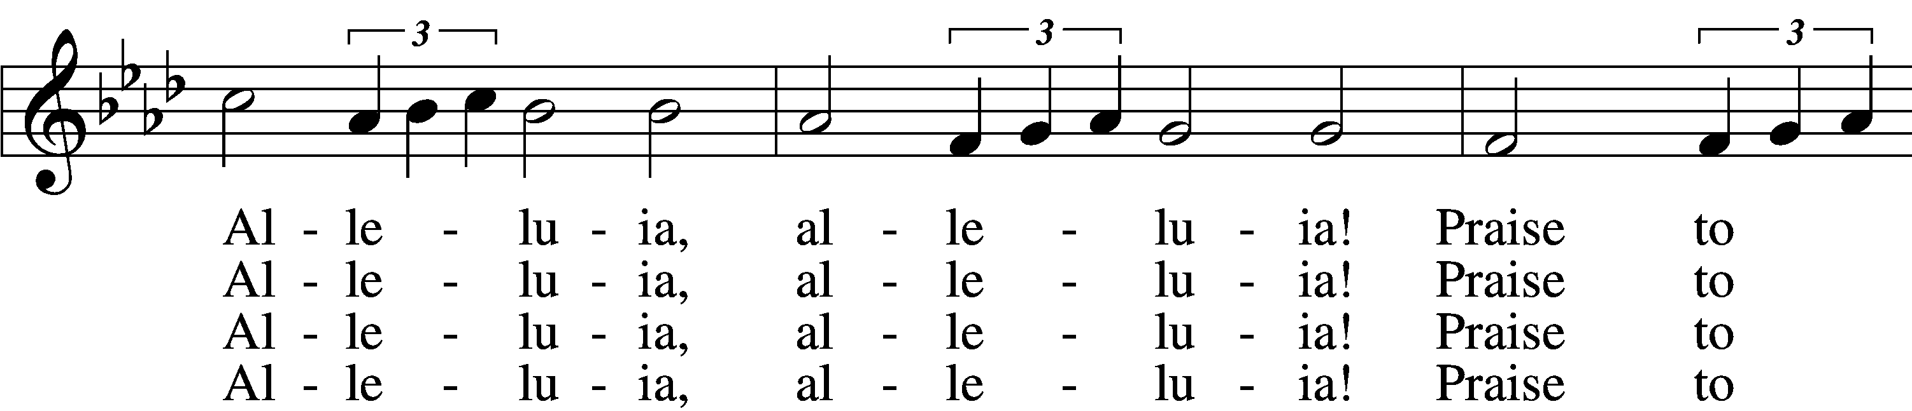
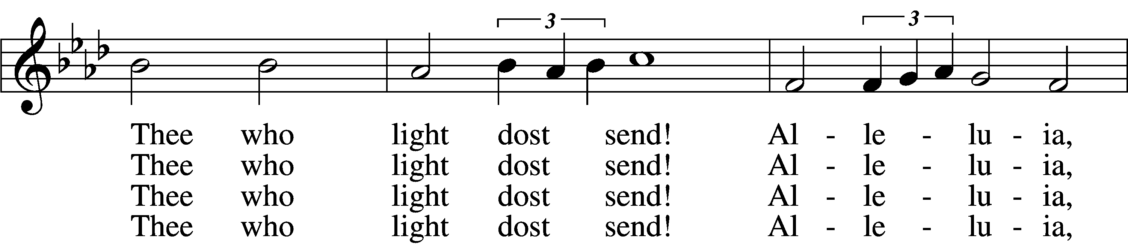
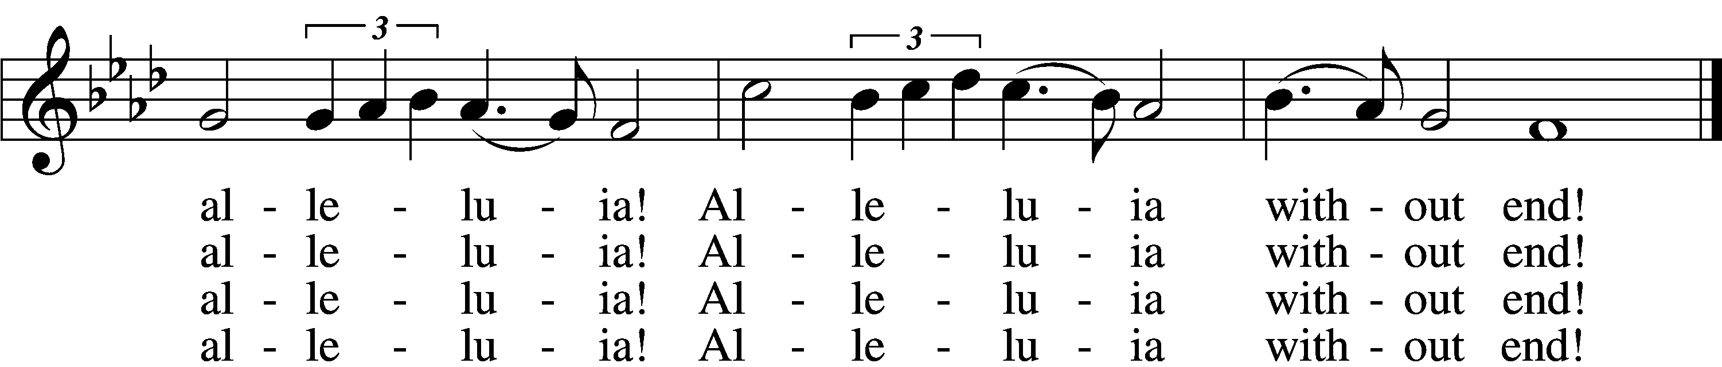

5 Give us lips to sing Thy glory,
Tongues Thy mercy to proclaim,
Throats that shout the hope that fills us,
Mouths to speak Thy holy name.
Alleluia, alleluia!
May the light which Thou dost send
Fill our songs with alleluias,
Alleluias without end!

D 6 God the Father, light-creator,
To Thee laud and honor be.
To Thee, Light of Light begotten,
Praise be sung eternally.
Holy Spirit, light-revealer,
Glory, glory be to Thee.
Mortals, angels, now and ever
Praise the holy Trinity!
Text: © 1969 Concordia Publishing House. Used by permission: LSB Hymn License no. 110002537
Tune: Public domain

SERMON
Please stand as able

PRAYER of the CHURCH
After each Segment:
P Lord, in Your Mercy,
C Hear our Prayer.
After Final Segment:
P Hear us as we pray in His name and as He has taught us:

LORD’S PRAYER
C Our Father who art in heaven,
hallowed be Thy name,
Thy kingdom come,
Thy will be done on earth
as it is in heaven;
give us this day our daily bread;
and forgive us our trespasses
as we forgive those
who trespass against us;
and lead us not into temptation,
but deliver us from evil.
For Thine is the kingdom
and the power and the glory
forever and ever. Amen.

SERVICE of the SACRAMENT

PREFACE LSB 208
P The Lord be with you.
C And also with you.
P Lift up your hearts.
C We lift them to the Lord.
P Let us give thanks to the Lord our God.
C It is right to give Him thanks and praise.
P It is truly good, right, and salutary that we should at all times and in all places give thanks to You, O Lord, holy Father, almighty and everlasting God, for the countless blessings You so freely bestow on us and all creation. Above all, we give thanks for Your boundless love shown to us when You sent Your only-begotten Son, Jesus Christ, into our flesh and laid on Him our sin, giving Him into death that we might not die eternally. Because He is now risen from the dead and lives and reigns to all eternity, all who believe in Him will overcome sin and death and will rise again to new life. Therefore with angels and archangels and with all the company of heaven we laud and magnify Your glorious name, evermore praising You and singing:
SANCTUS LSB 208
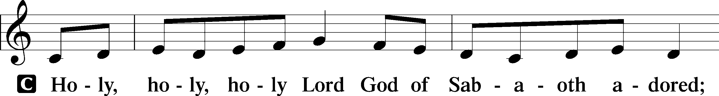
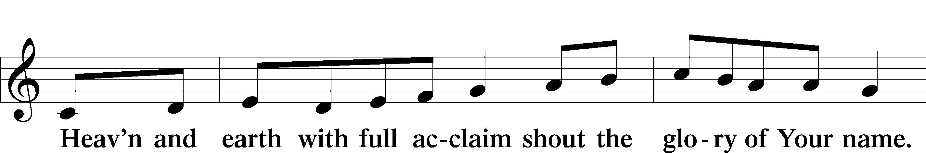
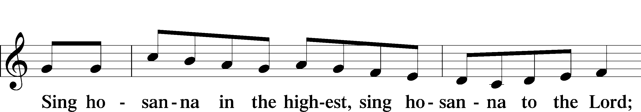

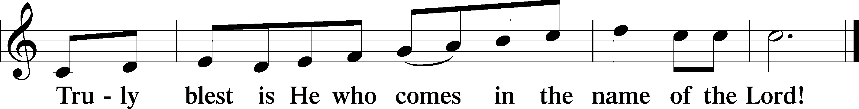

PRAYER OF THANKSGIVING
P Blessed are You, O Lord our God, king of all creation, for You have had mercy on us and given Your only-begotten Son that whoever believes in Him should not perish but have eternal life.
As the glory of Your presence once filled Your ancient temple, so in the incarnation of Your Son, Jesus Christ, You manifested the fullness of Your glory in human flesh.

We give You thanks that in His most Holy Supper You reveal Your glory to us. Grant us faithfully to eat His body and drink His blood so that we may one day behold Your glory face to face.

THE WORDS OF OUR LORD
P Our Lord Jesus Christ, on the night when He was betrayed, took bread, and when He had given thanks, He broke it and gave it to the disciples and said: “Take, eat; this is My T body, which is given for you. This do in remembrance of Me.”
In the same way also, He took the cup after supper, and when He had given thanks, He gave it to them, saying: “Drink of it, all of you; this cup is the New Testament in My T blood, which is shed for you for the forgiveness of sins. This do, as often as you drink it, in remembrance of Me.”
PAX DOMINI
P The peace of the Lord be with you always.
C Amen.
AGNUS DEI
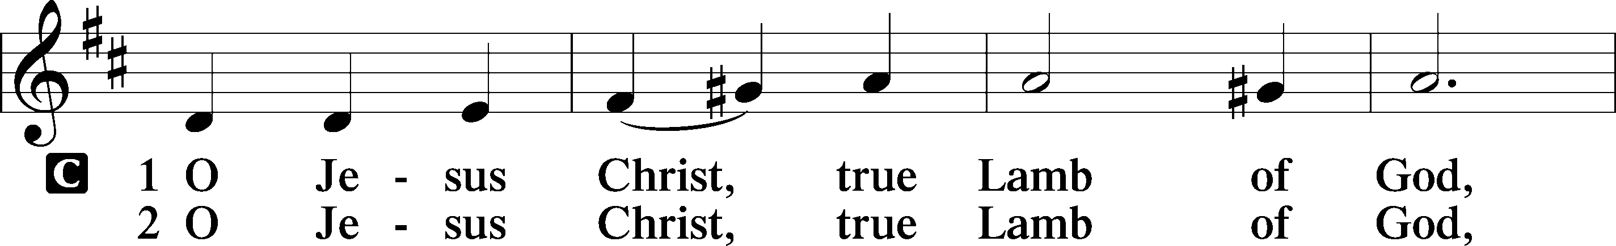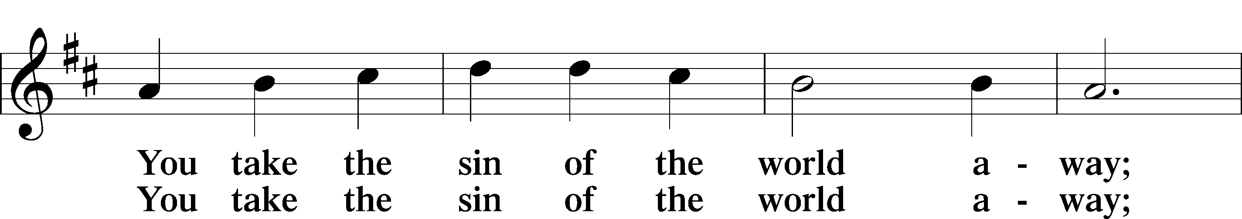
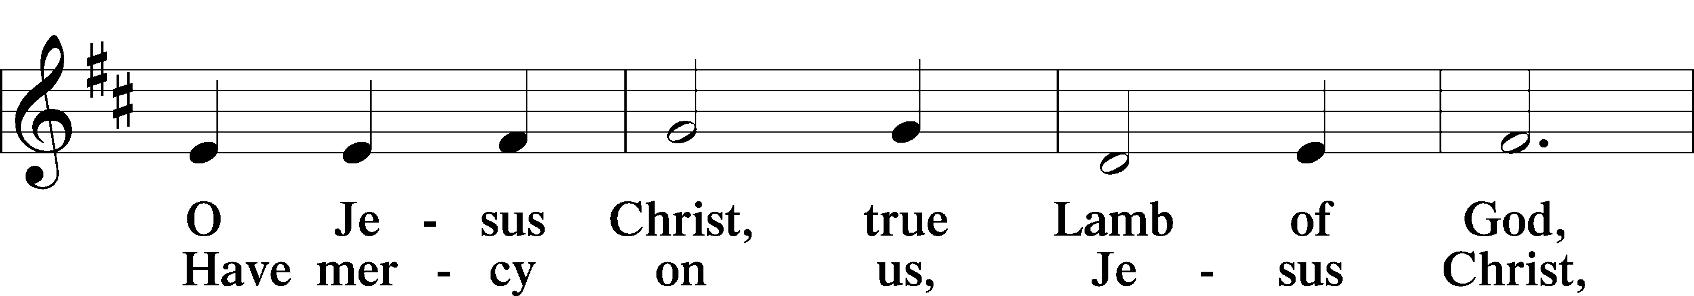
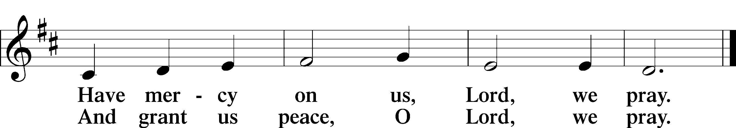

Please be seated
DISTRIBUTION
The pastor and those who assist him receive the body and blood of Christ first, then Communion will be served in a continuous fashion. Households may commune at the same time together. Ushers will help direct you forward via the center aisle; please return to your seats via the side aisles. Gluten-free bread is available for those who need it, as is non-alcoholic grape juice. Simply request either when you come forward to receive Communion.
DISTRIBUTION HYMN
My Hope Is Built on Nothing Less LSB 575
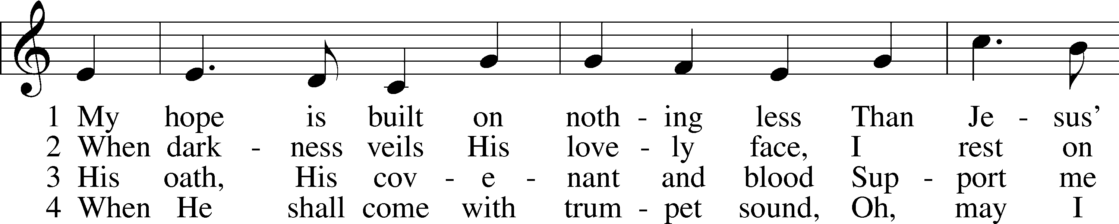
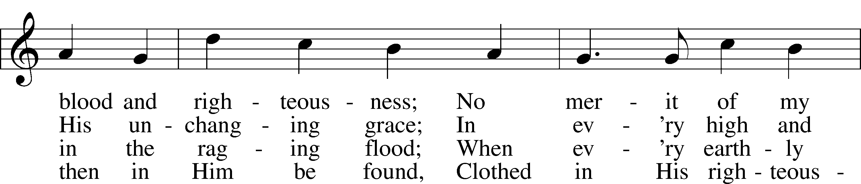
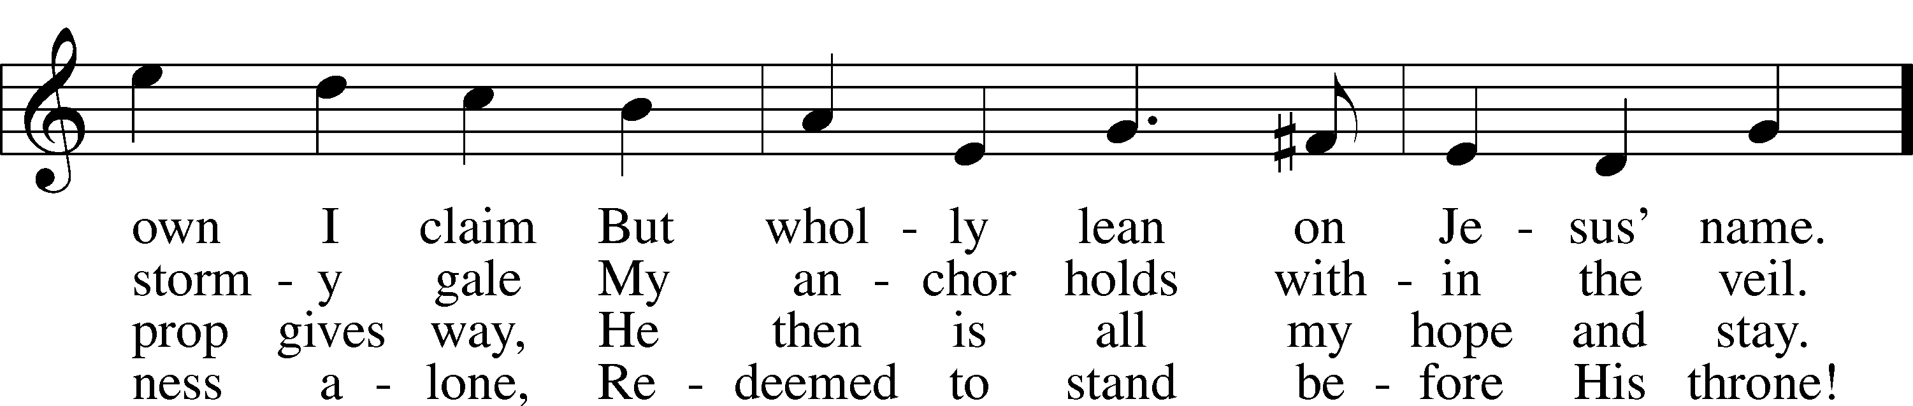
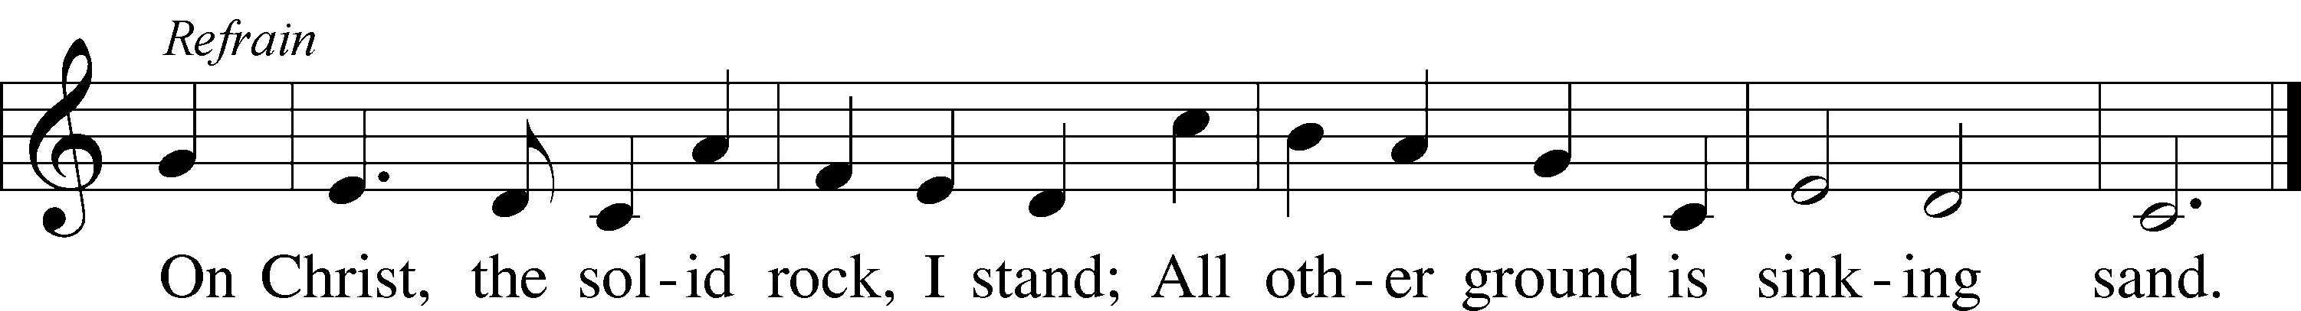
Text and tune: Public domain

Please stand as able

THE DISMISSAL
P The body and blood of our Lord Jesus Christ strengthen and preserve you in body and soul
to life everlasting. Depart T in peace.
C Amen.

NUNC DIMITTIS LSB 211
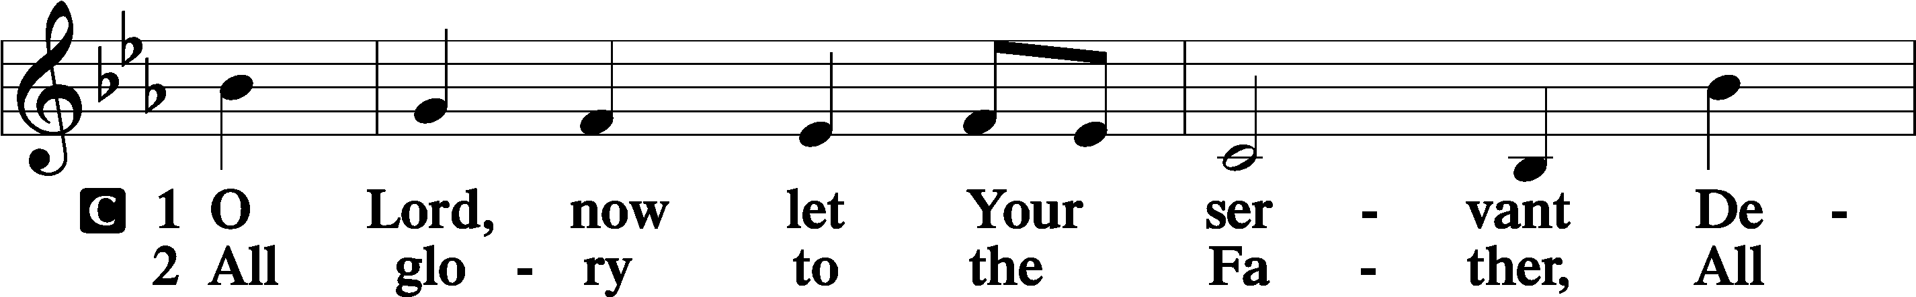
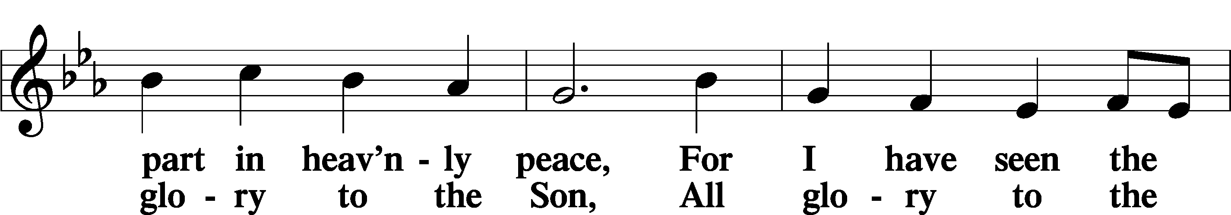
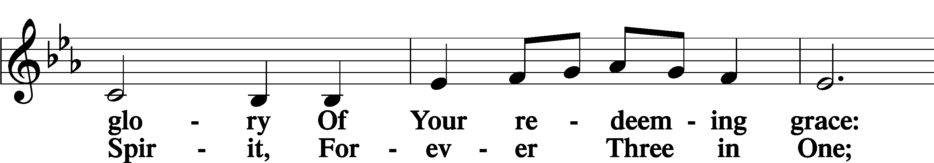
(Continued on next page)
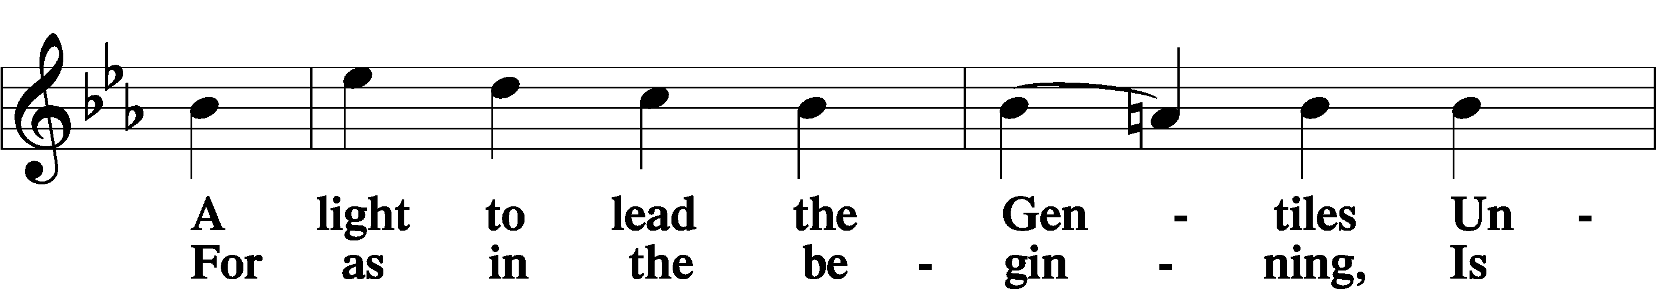
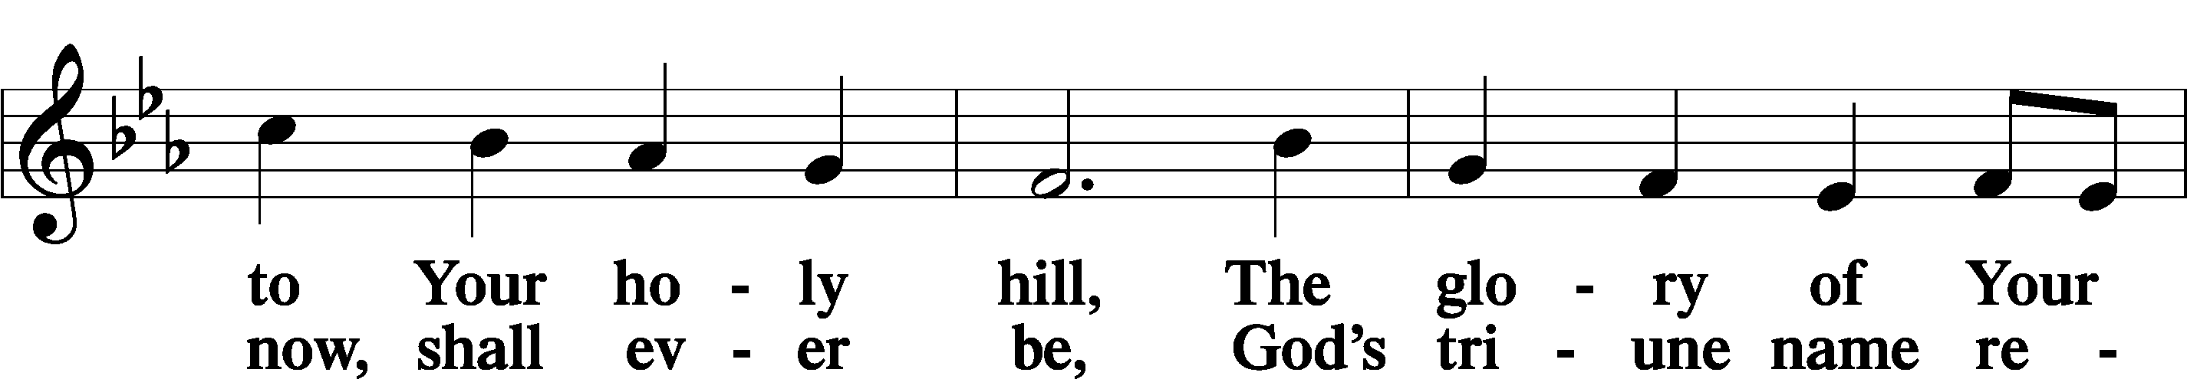
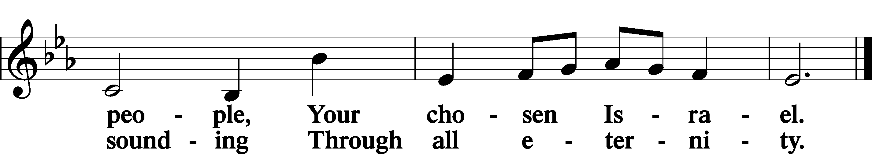

POST COMMUNION COLLECT
P Let us pray.
O God the Father, the fountain and source of all goodness, who in loving-kindness sent Your only-begotten Son into the flesh, we thank You that for His sake You have given us pardon and peace in this Sacrament, and we ask You not to forsake Your children but always to rule our hearts and minds by Your Holy Spirit that we may be enabled constantly to serve You; through Jesus Christ, Your Son, our Lord, who lives and reigns with You and the Holy Spirit, one God, now and forever.
C Amen.

BENEDICAMUS LSB 212
P Let us bless the Lord.
C Thanks be to God.

BENEDICTION
P The Lord bless you and keep you.
The Lord make His face shine on you and be gracious to you.
The Lord look upon you with favor and T give you peace.
C Amen.

Please be seated
CLOSING HYMN
Almighty Father, Bless the Word LSB 923 (Please stand on st.3)
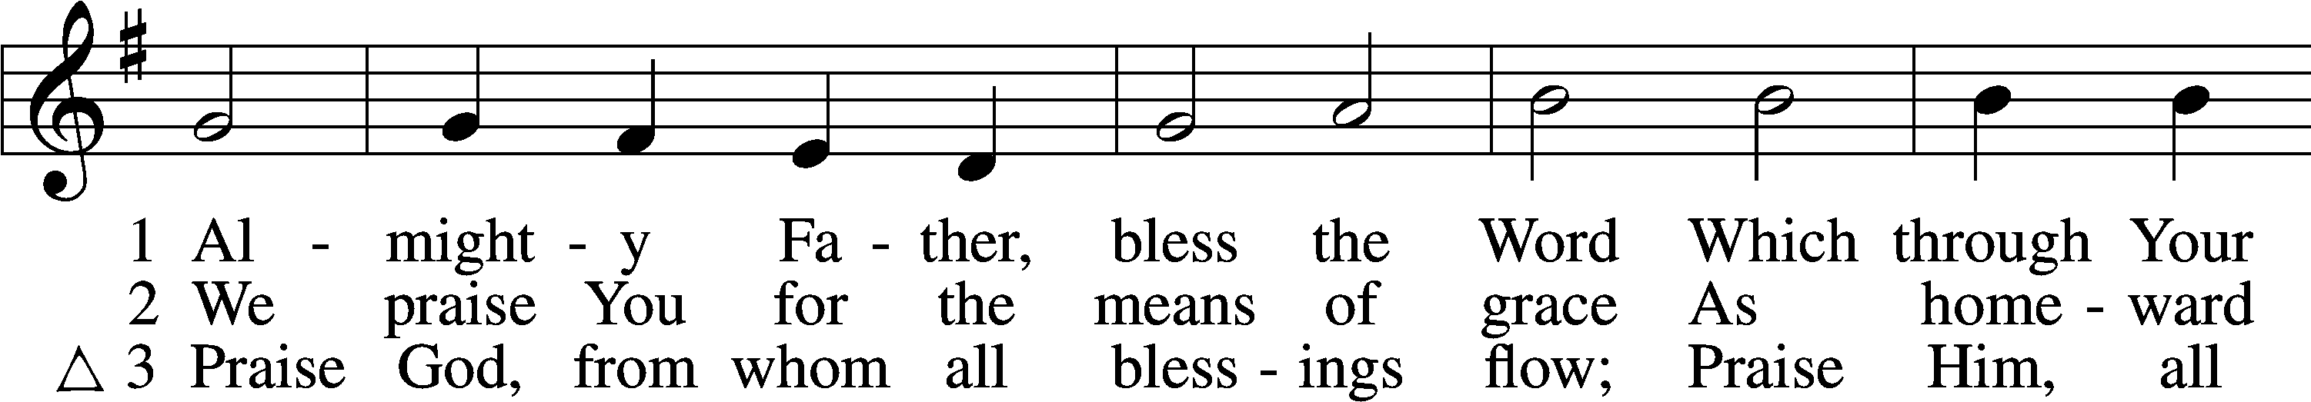
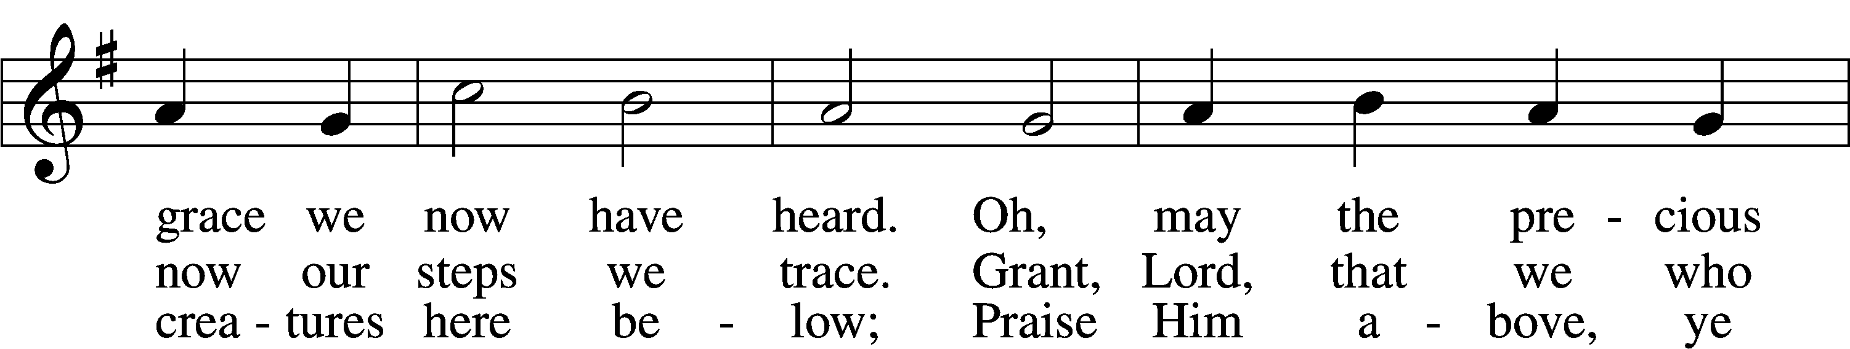
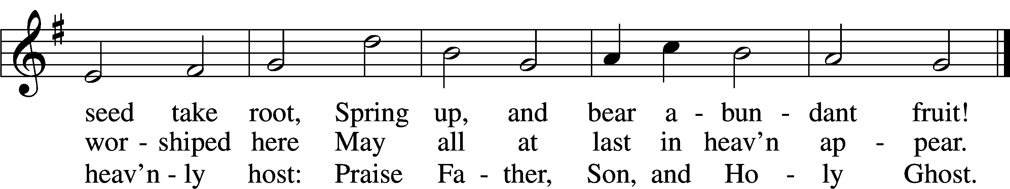
Text and tune: Public domain

ANNOUNCEMENTS and SENDING WORDS
P We go to live for Jesus!
C We go to share His love!

Acknowledgments
Unless otherwise indicated, Scripture quotations are from the ESV® Bible (The Holy Bible, English Standard Version®), copyright © 2001 by Crossway, a publishing ministry of Good News Publishers. Used by permission. All rights reserved. Created by Lutheran Service Builde

Next Week’s Readings
Old Testament: Isaiah 6:1-8 (9-13)
Epistle: 1 Corinthians 14:12b-20
Holy Gospel: Luke 5:1-11

SERVING in GODS HOUSE TODAY
Pastor: Rev. Ken Bernthal Counters: Larry Whitney, Wendell Smith
Elder: Tim Arner Altar Care: Karen Schneider
Ushers: Roxie Mohr, Dave Beyers Virtual Organist: Bob Erat
Greeters: Donna Cottrell, Leslie Martin Children’s Talk: Nancy Ely

PRAYERS
Please contact the office with updates to the prayer list. People will remain on the prayer list for 4 weeks before being removed. If they need to remain on the list, please keep Elaine informed and of any updates. This will help us to have a more accurate list. Thanks for your cooperation.

REMEMBER IN YOUR PRAYERS
Those who continue to grieve the passing of loved ones, Family of Richard Sherman, Family of Vi Erat, Family of Bob Breen, and Family of Peggy Scheedig.
Those with upcoming surgery:
Those recovering from surgery: Jennifer Martin.
Those with health concerns: Tiffany Amsdill, Laurie Breen, Hope Buchinger, Karen Christoff, Leslie Martin, Eleanor Raether, Beth Smith, and John Stutzman.
Those diagnosed with cancer: Leah Eicher, Rachel Frisch, Joe Gibson, Hope Osantowski, and Maria Freimark ( From Cancer & Friends Support Group).
Those under Hospice Home Care: Ruth Luebs, and Ken Williamson.

BIRTHDAYS: ANNIVERSARIES;
Delayni Brown Wendell & Dee Smith
Kayla Albrecht
Ann Mertz
Glenn Smith
Mary Arego
Tanner Beyers
Brock Wingo
George Bahlman
Janice Shafer
Karen Christoff

MESSAGES

ALTAR FLOWERS today are given to the glory of God in celebration of Laurie Breens Birthday.

MEMBER & GUEST CARDS: If you have not filled out a member/guest card, please take the time to fill one out and place it in the plate behind the back pews in our sanctuary.

WEDNESDAY MORNING BIBLE STUDY, 10:00am in the fellowship hall with Pastor Ken Bernthal.

GREETING CARDS If you are in need of some greeting cards, we carry an array of them in the cabinet in the library. The cost of the cards is posted on the cabinet. The money collected from the cards goes to LWML to help support Missions.

CRAFT DAY-Card Making: Saturday March 5th @ 1pm we will be starting our craft day. You will have a choice of 8 cards to make and you will be working with a card maker. The cost for this session is $20.00. If you want to make the cards and have a problem with the cost let Elaine in the office know. Please do not let cost make you shy away from coming, talk to Elaine we have another group that will help with the cost. This is the first time we are doing card making and have to get the kinks out of it. The group is limited to 20 people. Sign up sheet is in the narthex on the wall.

KUT-UPS will be meeting Monday February 7th and 21st at 10am in the fellowship hall.
CONGREGATIONAL MEETING: The Congregational Annual Report meeting will be held on February 6, 2022 after the church service. Please mark this date on your calendar.
Super Bowl Sub Sandwich Sale: You have an opportunity to order a great submarine sandwich on Super Bowl Sunday, and also support our Otsego County Food Pantry! LWML will be preparing sub sandwiches the morning of February 13th and selling
them for $6.50, with all the funds raised going to our local Food Pantry. Please pre-order your sandwiches by filling out the order form on our narthex shelf. There are several sandwich options from which to choose. Place your order form in the basket next to the order forms, please.

NEW MEMBERS: Glen & Elizabeth Smith, Karl & Laverne Scheiterlin, and Shirley Hildebrand will be received into membership on February 20th during the service and there will be a new member reception following the service.
DUAL PARISH CALL MEETING: Since Pastor Groleau has declined our call we will be discussing calling Pastor Mayland, . Our dual parish call meeting is scheduled for February 13th at Mt. Hope after their service approximately 12:00PM. I know that this is Super Bowl Sunday and Subway Sandwich sale, but there will still be time for those who wish to attend the meeting to make it to Grayling.

THIS WEEK AT TRINITY
January 30 Sunday
9:00 am Worship Service - Holy Communion – Rev. Ken Bernthal
10:00 am Fellowship & Coffee Hour
10:30 am Sunday Morning Bible Study W/ Dr. Tom Beach

January 31 Monday
7:00 pm Choir

February 1 Tuesday
3:00 pm Heart of the Pines Quilt Group
5:00 am Ladies Get-Together Dinner (Apple-bees)
6:30 pm Board of Elders Meeting

February 2 Wednesday
10:00 am Wednesday Morning Bible Study W/ Pastor Ken Bernthal

February 3 Thursday

February 4 Friday

February 5 Saturday
10:00 am Stephen Ministry Peer Supervision meeting.

February 6 Sunday
9:00 am Worship Service - Holy Communion – Rev. Paul Schneider
10:00 am Fellowship & Coffee Hour
10:30 am Bible Study with Dr. Tom Beach (Tutoring Room)

